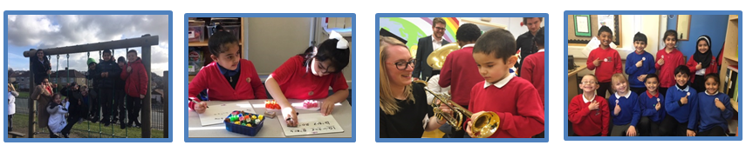
2 FANTASTIC Class Teachers Wanted
Are you committed to improving pupil outcomes? Hardworking with a sensor of humour?
We are looking for 2 class teachers to join our driven and passionate teaching team from July 2018. If you are ready for the challenge of a 2 form entry, forward thinking primary school then come and join us, as we continue our journey to Good.

You will need to be passionate, resilient and with the highest of expectations of our pupils as well as the ability to work as part of a flexible, happy team.

What Ofsted say (May 2016)
“A new team of senior leaders, ably led by the long-standing Headteacher, has brought renewed vigour and enthusiasm to the school.”

As one of our Teachers we can offer you:
- For the right candidate we will arrange staffing around you.
- Children who are motivated to learn
- For NQTs, a great development programme run by teachers and senior leaders in our very own cluster
- Access to great tailored CPD and opportunities for further promotion
- The support of working alongside other experienced teachers
- A straight talking and energetic team with a great sense of humour
Ready for the challenge?
If you think you are up to the challenge then contact the school to arrange an essential visit or to obtain an application pack.
Discover what a great career move working with us would be!

Contact: julie.taylor@grovehouseprimary.co.uk
Website: www.grovehouseprimary.co.uk Telephone: 01274 636921
Myers Lane, Bradford BD2 4ED
Closing date: Thursday 29th March 2018
Shortlisting: Thursday 29th March 2018
Interview: Wednesday 18th April 2018

